Meet Kenya: Africa’s Silicon Savannah
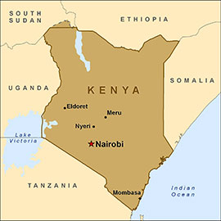
Fact File
Official name: The Republic of Kenya
Capital city: Nairobi, also known as the Green City in the Sun
Meaning of Kenya: God’s resting place
Motto: Harambee (Let us all pull together)
Main languages: English and Swahili
Largest tribes: Kikuyu, Luhya, Luo, Kalenjin, Kamba
Main cities: Nairobi, Mombasa, Kisumu, Eldoret
Geographical location: East Africa, bordered by South Sudan, Ethiopia, Somalia, Indian Ocean, Tanzania and Uganda
Population: About 45 million
Climate: Warm and humid tropical climate
Major economic activities: Agriculture, tourism, IT
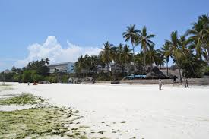
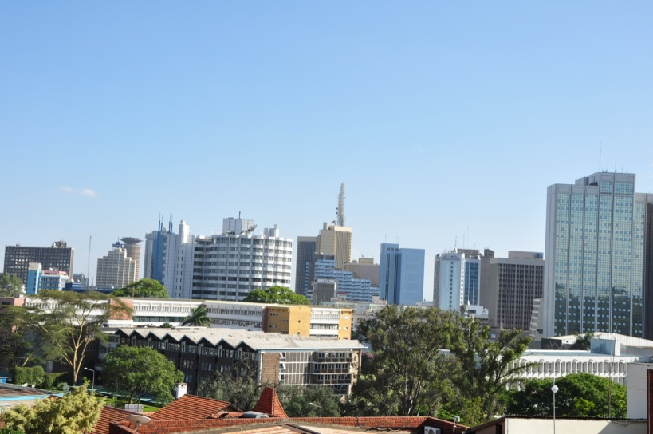
Describe the following pictures using the vocabulary below.
Mombasa
Nairobi

Vocabulary
- A city: Two cities
- A building: Two ................................
- A roundabout: Two..........................
- A tree: Two.......................................
- A tower: Two....................................
- A shrub: Two.....................................
- A skyscraper: Two..............................
- A roof: Two........................................
- Grass: A lot of....................................
- A street light: Two ...........................
- Sand: A lot of....................................
- A stone: Two......................................
Kisumu
