FLAGS OF AFRICAN COUNTRIES
1) Match the flags to their countries
NIGERIA

LIBERIA

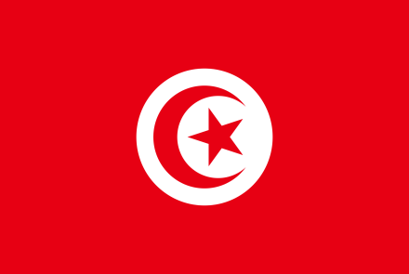
a) Malawi
SOUTH AFRICA

TUNISIA

b)Tunisia
MALAWI

BOTSWANA

c) South Africa

d) Botswana Countries Find the Special features in the flags
1) Malawi The rising sun,

e) Liberia

f) Nigeria
Explain African flags:
Instructions: Find the meanings of the elements in the African flags you studied
Use the following words or expressions to describe the flags’ meanings: ...stands for...; ....is symbolic of...;...symbolises...; ...is a symbol of...; ...shows...; ...illustrates...; ...describes...; ...represents...; ...means...;

1) The Malawian flag
a) The black stripe is a symbol of...................................................................................................................................
b) The red colour stands for.........................................................................................................................................
c) The green colour is symbolic of.................................................................................................................................

2) The Tunisian flag
a) .................................................................................................................................................................................
b) ................................................................................................................................................................................
c) ..................................................................................................................................................................................
d).................................................................................................................................................................................

3) The South African flag
a) .................................................................................................................................................................................
b) ................................................................................................................................................................................
c) ..................................................................................................................................................................................
d).................................................................................................................................................................................

4) The Liberian flag
a) .................................................................................................................................................................................
b) ................................................................................................................................................................................
c) ..................................................................................................................................................................................
d)..................................................................................................................................................................................

5) The Nigerian Flag
a) .................................................................................................................................................................................
b) ................................................................................................................................................................................
c) ..................................................................................................................................................................................

6) The Botswana Flag
a) .................................................................................................................................................................................
b) ................................................................................................................................................................................
c) ..................................................................................................................................................................................
d)..................................................................................................................................................................................

